genBOE Release 2.6
Enhancements:
- ISGS – Add Task and Resource (trip) level custom fields to travel tasks.
  - Issue:
    - Custom field options are not displayed for use by BOE authors in their travel tasks
  - Resolution:
    - Task and Resource level custom fields now display on the UI.
    - This shares and follows the same rules as current task/resource custom fields
    - Propricer export has been updated to support export of these fields
    - Output format templates have not been changed but may need to be to display these custom fields on the All BOEs export.
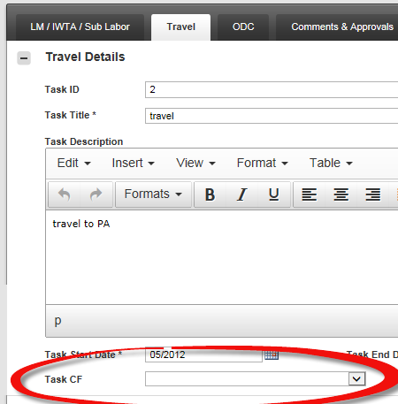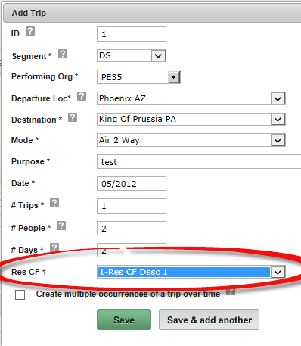

- ISGS – Implement faster Task Copying within a BOE
  - Issue:
    - BOE Authors that wish to replicate tasks within their own workspace/BOE need to use the Copy BOE/Task feature.
    - This process is time consuming and only performs a single copy of tasks within a source BOE.
  - Resolution:
    - “Duplicate Tasks” button has been added to the Edit BOE page.
    - Users can duplicate any task within their BOE
      - Currently limited to a max of 9 duplicates of a single task at a time due to performance concerns.
    - Multiple tasks can be duplicated at the same time
    - Duplicate feature is available on Labor, Travel and ODC tasks.
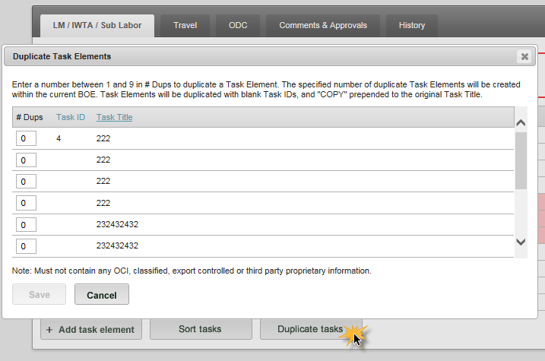
Wireframe: Duplicate Tasks

- MST – Add visual indicators to the Workspace Permissions page
  - Issue:
    - Users are given permission within a workspace but they may not have been granted access to the genBOE application.
  - Resolution:
    - Visual indicators have been added to the workspace permissions page
    - Users who are not found within the access AD groups will be flagged as not having access
    - Due to AD lookups this page may load slowly. Team can adjust this feature to be “on demand” via a check permissions button.
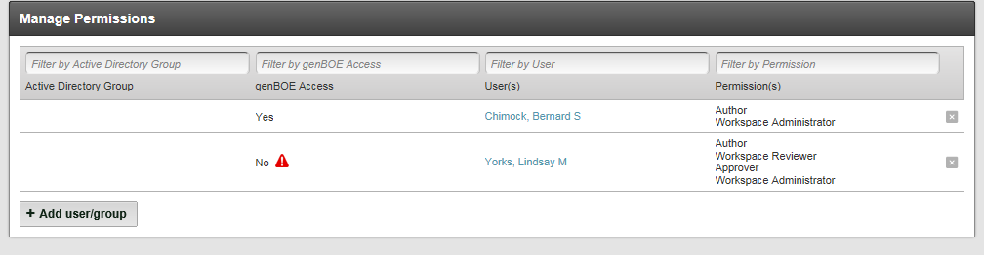

- ISGS – Add ability to Lock/Unlock individual BOEs in a Locked Workspace
  - Issue:
    - Workspace Admins Lock a workspace to perform a pricing run and need to unlock a workspace to allow for BOE edits. These edits may only influence one BOE and unlocking a full workspace allows for Authors to potentially make unanticipated edits.
  - Resolution:
    - Workspace admins can now unlock individual BOEs in a locked workspace for BOE Authors to make edits without changing the workspace state.
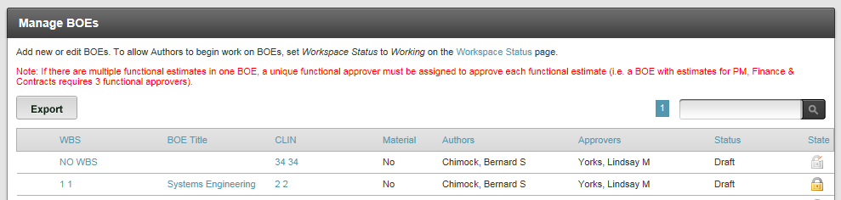
Wireframe: Lock/Unlock BOEs – Locked WS

- ISGS – Add ability to Submit for Approval/Approve/Reject/Review BOEs in a locked workspace.
  - Issue:
    - Workspace Admins Lock a workspace to perform a pricing run and need to unlock a workspace to allow for BOEs to move through the approval workflow. Unlocking a full workspace allows for Authors to potentially make unanticipated edits.
  - Resolution:
    - BOE Authors can now submit BOEs for Approval in a Locked workspace
    - BOE Approvers can now approve or reject BOEs in a Locked workspace
    - BOE Reviewers can now comment on BOEs in a Locked workspace
    - BOEs which are rejected in a Locked workspace will be set back to unlocked draft for edits to be made
Wireframe: Submit BOEs for Approval/Approve/Reject/Review in locked WS

Bug fixes/Performance:
- Word export performance issues with large workspaces and workspaces containing images.
  - Issue:
    - Larger proposals with rich text and images were slow exporting the preview in word or the All BOEs export
  - Resolution:
    - Export to word code has been optimized. Word exports overall complete quickly.
- Rich text formatting lost when exporting to word.
  - Issue:
    - Users have reported bullets points being misrepresented in the Word exports.
    - Users have reported text not matching up with what is shown on the UI
  - Resolution:
    - Word exporter has been updated to better retain formatting.
    - All Output Format Templates have been influenced by this change.
      - Exports will now look exactly as defined in templates
        - This may require re-evaluation to some template formats
- Additional validation checks + recalculate option added.
  - Issue:
    - Resource calculations, date shift adjustments, imports and recent calculation roll up bugs can create disconnects in totals.
    - Users are not alerted to issues that may exist with their resources + spreads + dates.
  - Resolution:
    - genBOE team continues to track down and fix all issues where data is creating disconnects/invalid total roll ups.
    - Validation on Edit BOE page will now highlight tasks which contain an error
    - BOE authors will be given a button to trigger an automated recalculation/adjustment to data within their task.
      - This button will perform automatic adjustment/recalculations
        - Dates will be adjusted, spreads will be recalculated
        - Any data which is being reported by the UI but unseen to the user triggering incorrect delta or spread totals will be removed
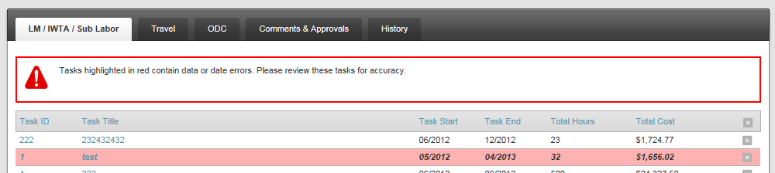
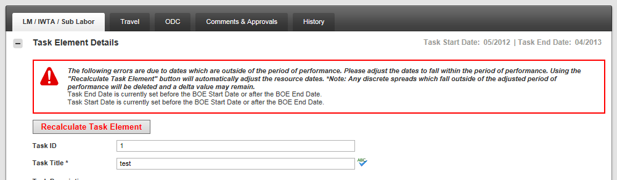

- Task validation was not showing correct error when both Start and End dates violate BOE PoP
  - Issue:
    - Edit Task validation was not displaying full error when both start and end dates for the task are in violation of the BOE’s period of performance.
  - Resolution:
    - Validation has been fixed to display both Start and End date error messages if both are in violation of the BOE PoP.
- Non-Exact Workspace Copy does not display correct URL.
  - Issue:
    - During a non exact copy of a workspace, the “Create Workspace: Verify” page displays an incorrect URL in the workspace identification section.
  - Resolution:
    - URL issue has been fixed, the correct URL is now displayed.
- BOE Summary Table not auto refreshing post task element deletion
  - Issue:
    - When a task element (labor) is deleted, the BOE summary section was not automatically refreshing to show the updated values.
  - Resolution:
    - Table will now refresh post task deletions
- ISGS Only – DTS Can be calculated for any resource with DTS prefixes (cost)
  - Issue:
    - DTS is calculated off of set ISGS resource prefixes (Ex: 1C)
    - If a new resource with rate type = cost was created, DTS would calculate using discretely entered costs as hours.
  - Resolution:
    - Issue was not reported or encountered, but was found during regression testing and DTS logic was updated to never consider cost type resources.
- Propricer template names which contain a ‘ or “ cause application error
  - Issue:
    - Propricer export templates which contain a ‘ or “ caused application errors and did not return the export files
  - Resolution:
    - The ‘ and “ characters are now stripped from template name upon save.
    - Database cleanup was applied to production when this bug was initially investigated.
- Invalid MOQ equation causes the All BOEs export to fail with application error
  - Issue:
    - User imported/saved a bad/incomplete MOQ equation, when the All BOEs export ran it failed with an application error.
  - Resolution:
    - Export code updated to attempt export despite this issue. If bad MOQ is unable to be resolved by the export code a more informative error has been added to alert the end user to the issue.
- Mange BOEs Export/Import – Can’t multi-select approvers
  - Issue:
    - Macro was broken in the Manage BOEs Excel import file
    - WS Admins were unable to select multiple approvers for bulk change/import
  - Resolution:
    - Macro has been fixed and multi-select is again available for approvers field
- Export to Propricer fails when a Resource is undefined in a task.
  - Issue:
    - Author copies a BOE from another workspace which contains custom resource names. The copy does not copy the custom resources and the Author is expected to correct this in their workspace. If this is not corrected exports can fail.
  - Resolution:
    - Export to Proricer error message added. Missing resource validation will alert the user to the issue and not return an application error
- Date shift: Performing a date shift after making MOQ Equation edits and adjusting resource spreads puts the task in an un-saveable state.
  - Issue:
    - Unsaved edits to a task before initiating a date adjust can put the task into an un-saveable state.
  - Resolution:
    - Additional validation added to prevent user from adjusting dates with unsaved changes.
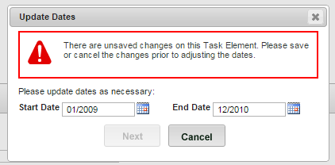
- Import/Export BOEs: Import of a BOE/Task with a Null (missing) resource returns system error
  - Issue:
    - Missing or null resource in BOE import file returns system error
  - Resolution:
    - Import logic has been updated to validate correctly
- Inconsistent disabled - Add Task, Duplicate Task and Sort Task buttons
  - Issue:
    - When feature buttons are disabled/hidden behavior is not consistent with each other across Labor, ODC and Travel tabs.
  - Resolution:
    - All buttons when disabled/enabled are consistent across edit boe tabs
- ODC Types Grid showing HTML Markup in read only view
  - Issue:
    - ODC Types grid was displaying HTML markup when page is in read only
  - Resolution:
    - Read only code updated to remove html markup
- MST Master template does not contain page breaks between BOEs
  - Issue:
    - MST Master template did not have page breaks between BOEs
  - Resolution:
    - Page breaks have been fixed in the template file
- Edit BOE/Edit Task – Navigating/Editing Resource Types Dates too quickly can result in spreads with incorrect dates
  - Issue:
    - Change resource 1’s start date, then quickly navigate to resource 2 and change its start date while the page is recalculating. This now throws off the date range of resource 2 and will allow save.
  - Resolution:
    - On page edits while recalculation has been restricted.
- Copy BOE/Task will not search or allow for copy of tasks from a DTS workspace
  - Issue:
    - Tasks within a DTS flagged workspace were not being searched for/returned via Copy BOE/Task.
  - Resolution:
    - Labor tasks are now searched/displayed to BOE Author for copy regardless of DTS workspace setting

UAT Environment:
ISGS: https://uat-genboe.isgs.lmco.com/
SSC: https://uat-genboe.ssc.lmco.com/
MST: https://uat-genboemst.us.lmco.com/
Note* Unlock/Lock BOEs feature has code currently under test and has not been built yet to UAT. This is related to the Lock/Unlock of workspace level rates. When a workspace is locked/complete/closed rates (labor, travel) are locked. When a BOE is now unlocked these rates are also unlocked (referencing system rates). As the unlocked BOE transitions to Awaiting Approval these rates were not again being locked. Also if multiple BOEs were unlocked, logic was not in place to account for the last submitted BOE or locked BOE to lock the rates. This update will be deployed to UAT after functional tests have been completed.

